Step 5: Ecommerce360
This optional Mailchimp feature adds details of customer purchases to list records in Mailchimp lists. You can then use Mailchimp segmentation to more precisely target your email marketing based on detailed customer purchase data.

Add the Tracking Script shown at the bottom of the Mailchimp configuration window to landing pages that will be targeted by your email campaigns.

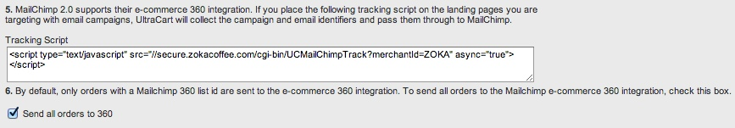

Step 6: Send all purchase data to Mailchimp lists
Select the check box to send order information from all transactions, not just those resulting from a Mailchimp campaign, back to your Mailchimp lists.

Helpful links:

What is Ecommerce360 and how does it work with MailChimp?

How do I view Ecommerce data in my MailChimp account?

